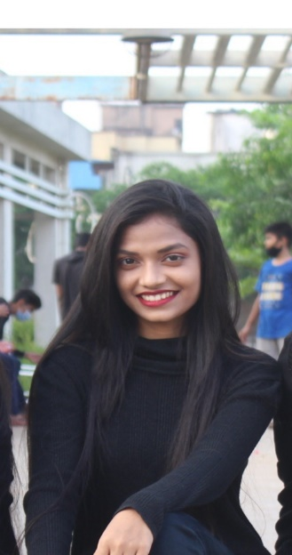

* 8422098689 / 9324844816

Envelope with solid fill mamtaghodke08@gmail.com

 Navi Mumbai - 400705

**OBJECTIVE EMPLOYMENT SUMMARY**

I am dynamic person and I look forward to an Name of Organization - DXC Technology

exciting and challenging career in an organization Designation – Desktop Support Associate

that could utilize my ability to maximum. Joining Date - **( 15 Dec 2021 )**

Project closure Date **– ( 31 Oct 2022 )**

**CAREER**

Project : MEDD (Medical Education and Drug Department ) HMIS (Health and Academics Management & Information System) Project.( On Fidelis Ind Pvt Ltd Payroll )

**ROLE AND RESPONSIBILITIES**

* Server monitoring and preparing checklist.
* Monitoring the servers , SLA ,and network switches through the NAGIOS.
* Network Configuration and basic level Troubleshooting.
* Preparing server checklist, SAN storage and Data centre physical verification reports.
* Requesting and coordinating vendor support for hardware support.
* Updating and maintaining OS and software.
* Managing the site in the absence of manager.
* Basic knowledge of REMOTE access tools-Secure Shell , No Machine ,Any desk.

**EDUCATIONAL PROFILES : TECHNICAL SKILLS :**

* B.sc-IT (University of Mumbai)

With 6.78 CGPA * Software installation

* HSC (Maharashtra state Board) * Operating System-Windows 7,8,

With 48.46 % 10 and RHEL .

* SSC (Maharashtra state Board) * MS Office(Excel , Word,

With 70% Power Point )

*HTML, CSS ,java, C++ ,PHP ,Angular

**CERTIFICATIONS COURSES** : **PERSONAL INFORMATION:**

* MSC-IT *Father Name – Ramesh Sakharam Ghodke
* Advance java programming using Angular *Mother Name – Sujata Ramesh Ghodke

(FROM ANUDIP FOUNDATION *Adress – Railway colony RB/1, B/R-8/5,

UNDER ACTIVITY OF CAPGEMINI) sec-22 ,JUINAGAR Navi Mumbai

* CYBER SECURITY & DATABASE *DOB – 08 JUNE 2000

RECOVERY (FROM BARTI INSTITUTE) *Language knowns – Marathi , Hindi, English

* ENTREPRENEURSHIP DEVELOPMENT * Marital Status – Unmarried.

(FROM BARTI INSTITUTE) * Hobbies – Books reading , Story writing ,

Dancing , Cooking.

Dancing , Cooking.